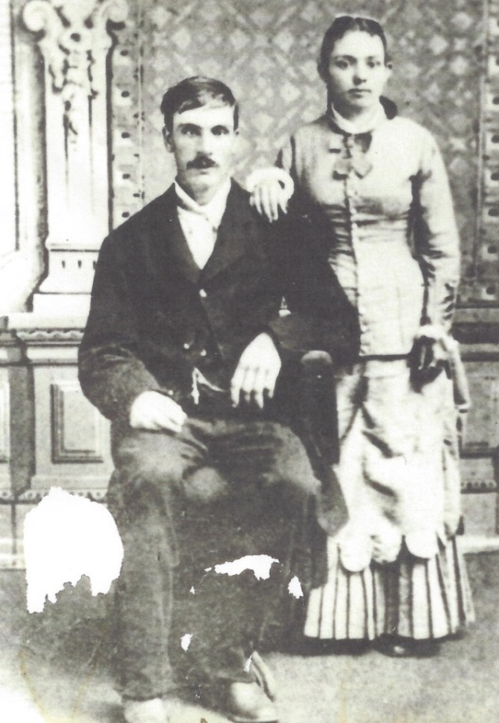

**Aaron Brazil and Elizabeth Morris Worthen – 1879**

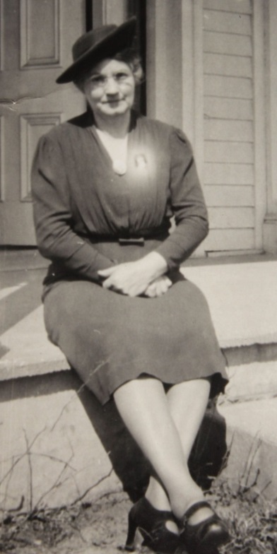

**Josephine Sybil Worthen Wolfe –1930**